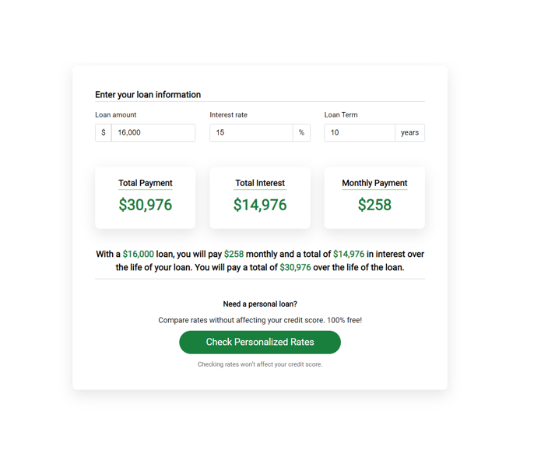

I would like to make a profit each year of

­­­­­­­­

My average

I want to earn I want to take off My business amount I charge

weeks each year costs are for my services is

£

£ per year

£ per month

The average amount you will earn each day / week / month will be:

£XXX

£XXX

£XXX

Per DAY Per WEEK Per MONTH

The total number of appointments or sales you need to have will be:

Per DAY Per WEEK Per MONTH

To earn **£XXX** a year you will earn **£X** per week and need to book in **Y appointments / sales** each week to achieve this.

­­­­­­­­­­______________________________________________________________________________________­­­­­­­­

Do you need to understand exactly what you’re making in your business

so that you're not left feeling anxious or confused?

Sign up for your FREE Pocket PA Trial here

** This does not include tax & national insurance costs. Remember, you will need to budget an amount for Tax & National insurance as well, but Pocket PA has a tax estimator tool to help you with that too!